HACKATHON 1

Question 3: Municipal Waste Collection Optimizer
3a) Data Types:
Write a Java program to store and display the following details of a waste collection vehicle:
- Vehicle number – integer
- Waste collected in kilograms – decimal value
- Number of collection points – integer
- Vehicle status – character
Use appropriate Java data types for each value and display all the details.
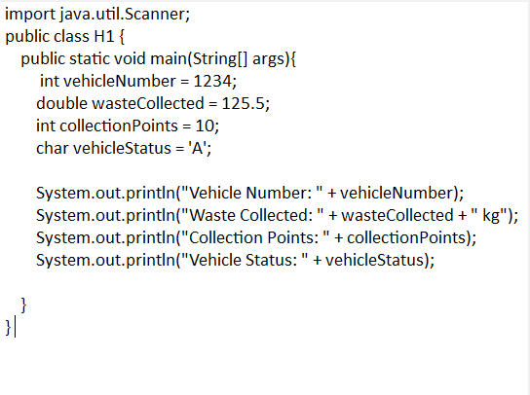

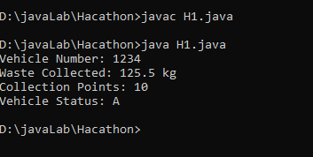

3b) If-Else Condition:
Write a Java program to check the waste collection status based on the amount of waste collected. Read the waste collected in kilograms.
- If the waste collected is 100 kg or more, display "Collection Target Achieved".
- Otherwise, display "More Waste Collection Required".
Use an if-else statement.
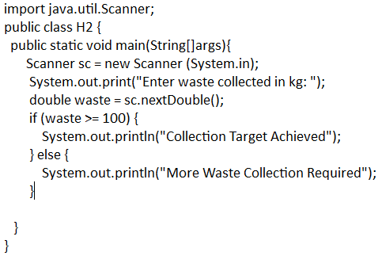
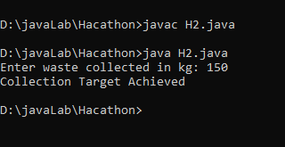

3c) Methods:
Write a Java program to calculate the total waste collected from two collection points using a method.
Create the following method:
calculateTotalWaste(double point1Waste, double point2Waste)
The method should return the total waste collected. Read the waste collected at the two collection points from the user, call the method, and display the total waste collected.
